**WARDROBE is a furniture where you put clothes**

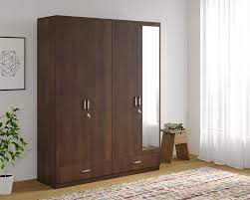

**CHEST OF DRAWERS furniture with drawers**

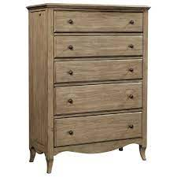

**CUPBOARD furniture with door and shelves/police**

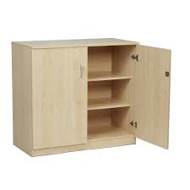

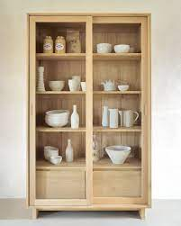

**BOOKCASE furniture for books**

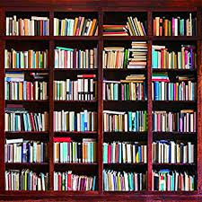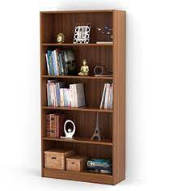

**SOFA you sit there with your family and you watch TV**

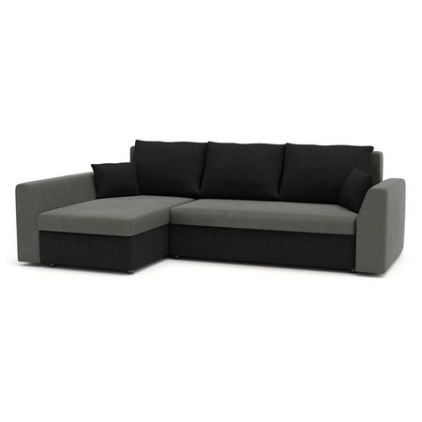

**ARMCHAIR for 1 person to sit and watch TV**

